**TWO STAGE PIPELINE**  
**EXP NO: 37**

**AIM:**To write a C program to implement two stage pipelining.

**PROCEDURE:**  
Step1:Start  
Step 2: Initialize the counter variable to 1.  
Step 3:.Prompt the user to enter the first number (a).  
Step 4:.Read the first number (a) from the user.  
Step 5:Increment the counter by 1.  
Step 6:Prompt the user to enter the second number (b).  
Step 7:Read the second number (b) from the user.  
Step 8:.Increment the counter by 1.  
Step 9:Display the menu of operations: Addition, Subtraction, Multiplication, and Division.  
Step 10:Prompt the user to select an operation (choice).  
Step 11:Read the choice from the user.  
Step 12:Use a switch statement to perform the operation based on the selected choice:         
12.1For choice 1: Perform addition (res = a + b). Increment the counter by 1.         
12.2For choice 2: Perform subtraction (res = a - b). Increment the counter by 1.  
12.3. For choice 3: Perform multiplication (res = a * b). Increment the counter by 1.         
12.4 For choice 4: Perform division (res = a / b). Increment the counter by 1.         
12.5. For any other choice: Display "Wrong input".   
Step 13: Display the value of the counter (the number of cycles taken).  
Step 14:Prompt the user to enter the number of instructions (ins).  
Step 15:Read the number of instructions (ins) from the user.   
Step 16:Calculate the performance measure by dividing the number of instructions (ins) by the counter and store it in the  
performance measure variable.  
Step 17:Display the performance measure  
Step 18:End  
**PROGRAM:**  
**#**include<stdio.h>  
int  
main()  
{  
            int counter =1,a,b,choice,res,ins;  
            printf("Enter number 1:");  
            scanf("%d",&a);  
            counter = counter+1;  
            printf("Enter number 2:");  
            scanf("%d",&b);  
            counter = counter +1;  
            printf("1-Addition:\n2-Subtraction:\n3-Multiplication:\n4-Division:");  
            scanf("%d",&choice);  
            switch(choice)  
            {  
                        case 1:  
printf("Performing addition\n");  
                                                res = a+b;  
                                                counter = counter+1;  
                                                break;  
                        case 2:  
printf("Performing subtraction\n");  
                                                res = a-b;  
                                                counter = counter+1;  
                                                break;  
                        case 3:  
printf("Performing Multiplication\n");  
                                                res = a*b;  
                                                counter = counter+1;  
                                                break;  
                        case 4: printf("Performing Division\n");  
                                                res = a/b;  
                                                counter = counter+1;  
                                                break;  
                        default:  
printf("Wrong input");  
  
  
                                                 break;  
  
  
            }  
  
  
            printf("The cycle value  
is:%d\n",counter);  
  
  
            printf("Enter the number of  
instructions:");  
  
  
            scanf("%d",&ins);  
  
  
            int performance_measure =  
ins/counter;  
  
  
            printf("The performance measure  
is:%d\n",performance_measure);  
  
  
            return 0;  
  
  
             
  
  
}  
  
  
   
  
  
   
  
  
   
  
  
   
  
  
**INPUT:**  
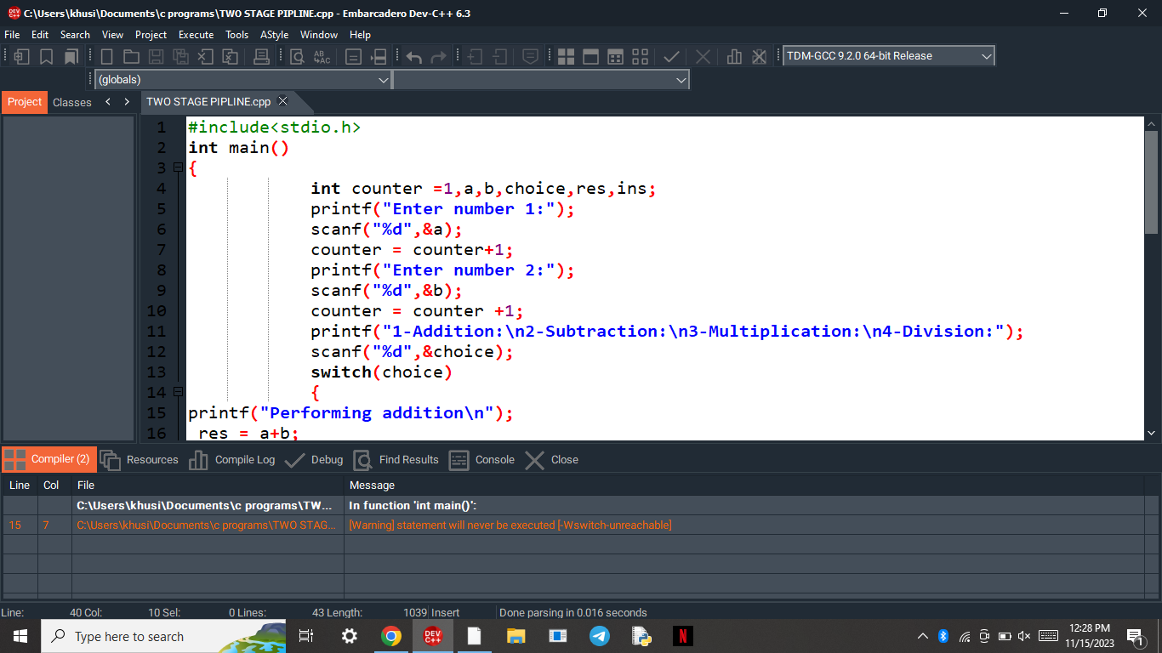  
  
  
  
  
  
  
  
  
  
  
  
  
  
  
  
  
**OUTPUT:**

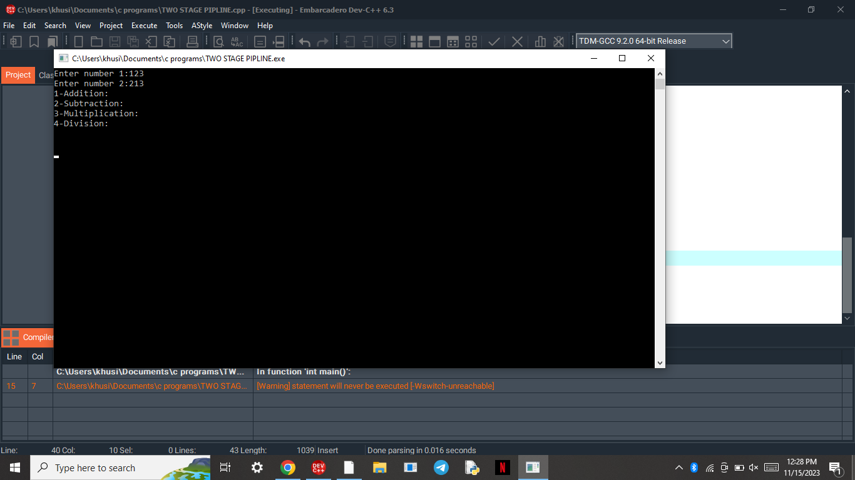  
  
  
   
  
  
  
  
  
  
  
  
  
  
  
**RESULT:**Thus  
the program was executed successfully using DevC++.